Parent’s Guide To Cub Scouting

Where character counts and the adventure begins...

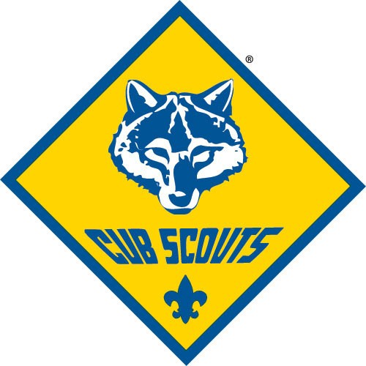

Cub Scout Pack 25 – Long Hill Methodist Church

Shelton, CT

Housatonic Council, Cub Scouts of America
Updated: June, 2017

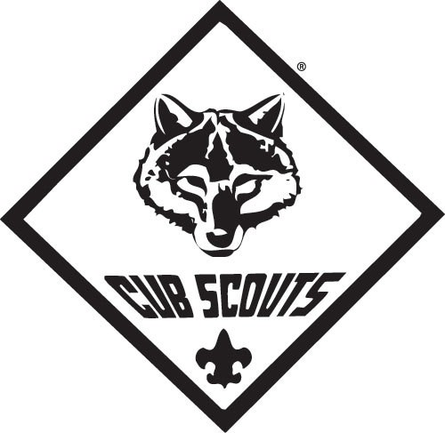
Purposes of Cub Scouting
Cub Scout packs serve boys who are in Kindergarten through fifth grade (or 6 through 10 years of age). Boys, families, leaders, and chartered organizations work together to achieve the purposes of Cub Scouting.

The Ten Purposes of Cub Scouting are:

Character Development
- Spiritual Growth
- Good Citizenship
- Sportsmanship
- Family Understanding
- Respectful Relationships
- Personal Achievements
- Friendly Service
- Fun and Adventure
- Preparation for Boy Scouts

“In the 30 years that I’ve been doing this for a living, I’ve never had a parent say to me, ‘I regretted the time I spent with my son or child in Scouting.”

-Roy L. Williams, Former Chief Scout Executive, Boy Scouts of America

Your Son, Scouting, And You…
An Aid To Parents
As a parent, you want your son to grow up to be a self-reliant, dependable and caring individual. Scouting has these same goals in mind for him. Since 1910, we have been weaving lifetime values into fun and educational activities designed to assist parents in strengthening character, good citizenship, and physical and mental fitness in youth.

Scouting teaches family values. We know that boys do not join Scouts to get their character built. Boys join because it is fun filled with adventure.

The Cub Scout Pack
The pack is a group made up of several dens: Lion Cub, Tiger Cub, Wolf Cub, Bear Cub, and Webelos Scout dens. Our pack has a den for each grade level.

The pack is led by a CubMaster during the pack meeting. The CubMaster leads pack meetings with games, skits, stunts, songs, ceremonies, and presentation of badges which the boys earned that month. The pack meets once a month.

Tiger Cub Den - 1st Grade

Tiger Cubs is a fun program that introduces first-grade boys and their adult partners to the excitement of Cub Scouting as they “search, discover, and share” together.

Tiger Cubs are organized into a Tiger Cub den, which usually consist of four to eight boys and their adult partners. Every week the Tiger Cub den comes together for an activity built around the “big idea” that has been selected by the den. Leadership of the den meetings is shared among the adult partners with guidance from the Tiger Cub den leader. The Tiger Cub den also attends the monthly Cub Scout pack meeting. At the end of the school year, in May, Tiger Cubs graduate and become part of a Wolf Cub Scout den.

Cub Scout Dens

2nd (Wolf) and 3rd (Bear) Grades
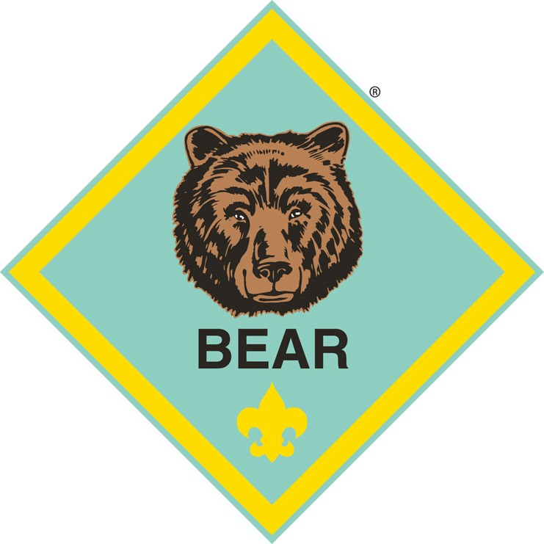
Cub Scouts are 8- or 9-year-old boys who are in the second or third grade. Cub Scout den meetings are run by an adult den leader with the help of an assistant den leader and if available, a Boy Scout den chief. Meeting activities are planned around monthly themes and include playing games, making handicrafts, taking hikes and other outdoor activities, and taking part in simple ceremonies and songs. Sometimes work on advancement requirements is included.

When they complete the third grade (o reach age 10), the boys graduate to a Webelos Scout den.

Webelos Den

4th and 5th Grade
Webelos, which stands for “WE’ll BE LOyal Scouts”, is a program for boys who are 10 years old and have completed the third grade. A boy may begin working on the Webelos badge as soon as he joins a Webelos den. This is the first step in his transition from a Cub Scout pack to a Boy Scout troop. As a Webelos Scout completes the requirements found in the Webelos Scout Book, he will work on activity badges, attend meetings led by adults, and become familiar with the Boy Scout requirements -- all leading to the highest award a boy can earn as a Cub Scout, the Arrow of Light Award.

Webelos Scouts may wear the blue Cub Scout or khaki Boy Scout uniform. Webelos cap, neckerchief, and insignia placement is the same for either uniform. They can choose the blue belt with the Webelos Scout buckle or the olive belt with the Boy Scout buckle. Cub Scout belt loops are only for the Cub Scout web belt.

Scouting is fun with a purpose!

The Advancement Plan
The responsibility of a boy’s advancement in Cub Scouting lies with the family and not with the pack. Some advancement requirements are done at den meetings, but most are done at home with the family.

Tiger Cubs– 1st Grade
The Tiger Cub program is for first-grade (or age 7) boys and their adult partners. There are five Tiger Cub achievement areas. The Tiger Cub, working with his adult partner, completes 15 requirements within these areas to earn the Tiger Cub badge. These requirements consist of an exciting series of indoor and outdoor activities just right for a boy in the first grade.

Bobcat
All boys, in 1st thru 5th-grade earn the Bobcat badge first, by learning the Cub Scout Promise, Law of the Pack, handshake, salute, sign, motto, and meaning of “Webelos.” After receiving the Bobcat badge, each boy works on requirements based on his grade level.

Wolf – 2nd Grade
A Cub Scout who has completed first grade (or is age 8), works on 12 achievements to earn the Wolf badge. After he earns his Wolf badge, a boy may work on electives in different interest areas until he is old enough to begin work on the Bear rank.

Bear – 3rd Grade
A Cub Scout who has completed second grade (or is age 9), works to complete 12 of 24 achievements to earn the Bear badge.
After he earns his Bear badge, a boy may work on electives in different interest areas until he is old enough to begin work on the Webelos rank.
Webelos– 4th and 5th Grade
When a Cub Scout has completed the third grade (or becomes 10 years old), he transfers to a Webelos den, led by an adult Webelos leader. The boy works on requirements for the Webelos badge, 20 activity badges, and the Arrow of Light Award (the highest award in Cub Scouting). Camping and outdoor programs are an important part of the 18-month Webelos program. In February of a Webelos Scout’s 5th grade year, he graduates from Cub Scouting into the adventure of Boy Scouting at an impressive graduation ceremony. Every boy deserves an opportunity to be a Boy Scout.

Belt Loops
Throughout the year, Cub scouts earn belt loops to show their progress, and proudly display the achievements and learning they have accomplished. Some belt loops are required as a prerequisite to earning the next rank, others are electives. Belt loops are normally awarded at pack meetings, but can be awarded at den meetings.

What We Do In Pack 25

The scouts are given several opportunities to participate in activities both with the Pack as well as with their individual Dens. Many activities are for scout advancement or awards while others are just for the fun of it.

Den Meetings and outings are set directly for the scouts and in the Tiger Dens, their adult partner.

Past Den Outings have included visits to police stations, nature hikes, fishing, visits to local museums, sporting events and over-night (back yard) camp-outs.

Pack Night is set for the Scouts, however we recognize Pack Night as Family Night. Pack Night is a great opportunity for families to do something as a family with friends which is an awesome opportunity in the development of our children. Pack Nights include flag ceremonies, award ceremonies, skits, silly songs, silly stories and fun activities.

Pack Activities and Outings are a great time and often include the whole family.

Pack Meetings, Activities and Outings are scheduled during the school year (September through June). However, the Pack also meets once a month during the summer for a fun-filled activity – such as the Discovery Museum or a Bridgeport Bluefish game.

Who Pays For Scouting?

Youth Members...
Assisted by their parents or guardians, boys in Cub Scouting, Boy Scouting, and Varsity Scouting and young men and women in Venturing pay their share from personal savings and participation in money- earning projects. Members buy their own uniforms, handbooks, and personal equipment and pay their own activity dues, outing and camp fees.

Pack 25 also hosted fundraisers through the year to raise money for pack events and to off-set the cost of meetings and charter. The biggest fundraising event is the annual popcorn drive (September through November).Community Organizations...

Each chartered organization using the Scouting program provides a meeting place and adult volunteer leadership for its BSA unit(s). The chartered organization and local council must approve unit money-earning projects before the launch of the project.
The Housatonic Council...
Each year the Housatonic Council establishes a budget to provide unit service, administration, training, outdoor and camping facilities, and quality program activities in the continuing effort to serve more boys. Just as our pack raises funds for operation through dues and money-earning projects, the council raises funds for council operation through various methods.

And the National Organization.
Funds to support the national organization of the Boy Scouts of America come from registration fees, local council service fees, investment income, Scouting and Boys’ Life magazines, sale of uniforms and equipment, contributions from individuals, and foundation grants. These monies help to deliver the program of the BSA (through four regional service centers and more than 300 local councils) to chartered organizations that use the Scouting program to meet the needs of their youth.operation through dues and money-earning projects, the council raises funds for council operation through various methods.

What Will Scouting Cost Me?
Prices on list were taken from the 2017 Boy Scouts of America catalog. Prices are subject to change - Visit www.scoutstuff.org for additional items and information.

Minimal
Registration $24.00
Pack Dues $70.00/Year

Optional
Boys’ Life Magazine $12.00/Year
Shirt short sleeve (blue) | $24.99 | Den Outings/Activities (Determined by Den) Pack Outings/Activities (Determined by Pack)
Pants (blue) | $24.99
Hat | $14.99 | Pack Provides:
Council shoulder patch | $3.35 | Class B Pack T-shirt
Den numeral | $1.49 | Pinewood Derby Cars
Unit numeral | $2.98 | Belt Loops / Pins
Cub Scout belt | $9.99 | Rank advancements
Neckerchief | $9.99 | Pack Night activities and entertainment
Neckerchief slide | $5.99 | Awards and patches
Socks | $5.99
Scout Handbook | $12.99

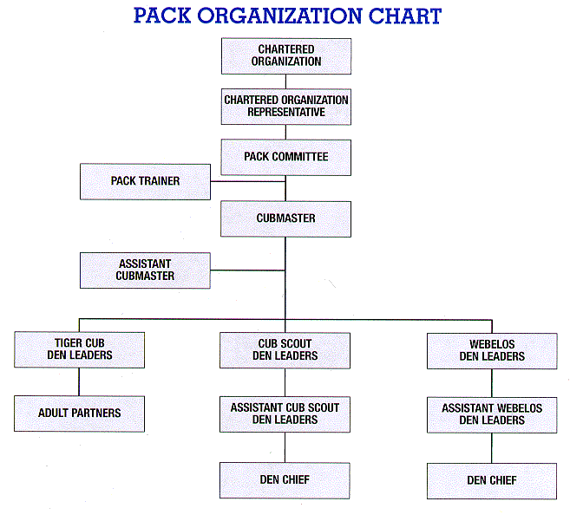
The Pack is run by the Pack Committee which:
- Selects leadership
- Finds meeting places
- Performs record keeping
- Manages pack finances
- Orders badges
- Maintains pack equipment
- Helps train leaders
- Recognizes leaders

All of the leaders in the pack get together once a month to finalize details of each monthly program.

Packs are owned by Chartered Organizations which:
- Include parent-school organizations, religious organizations, service clubs, and other organizations interested in youth.
- Approves leadership, helps secure a meeting place, keeps the pack within the organization’s and Boy Scout guidelines and policies.
- Selects a chartered organization representative (a liaison between the pack and its chartered organization).
- The Chartered Organization for Cub Scout Pack 25 is Long Hill Methodist Church.

What Do You Receive As An Adult Leader?
Being a leader is fun, challenging, and rewarding. Leaders find their experiences help them to become better parents. The following are some of the many dividends that will enrich your life as you dedicate your time, talent, and enthusiasm to Scouting:

- Fun and fellowship with other families, sharing your pride in the boys’ accomplishments.
- The privilege of helping to enrich and strengthen families.
- A chance to help boys learn good citizenship and to help shape them into men who have strength of character and are sensitive to the needs of others.
- The opportunity to help make a difference in the lives of boys as they grow strong in mind and body.
- A code to live by which will set a worthwhile example for both boys and adults.
- The satisfaction of being a member of a world-wide movement, and pride in being publicly identified as a part of this organization – wearing the Scouting uniform is a visible means of showing you believe in and stand up for the ideals and objectives of the Boy Scouts of America.
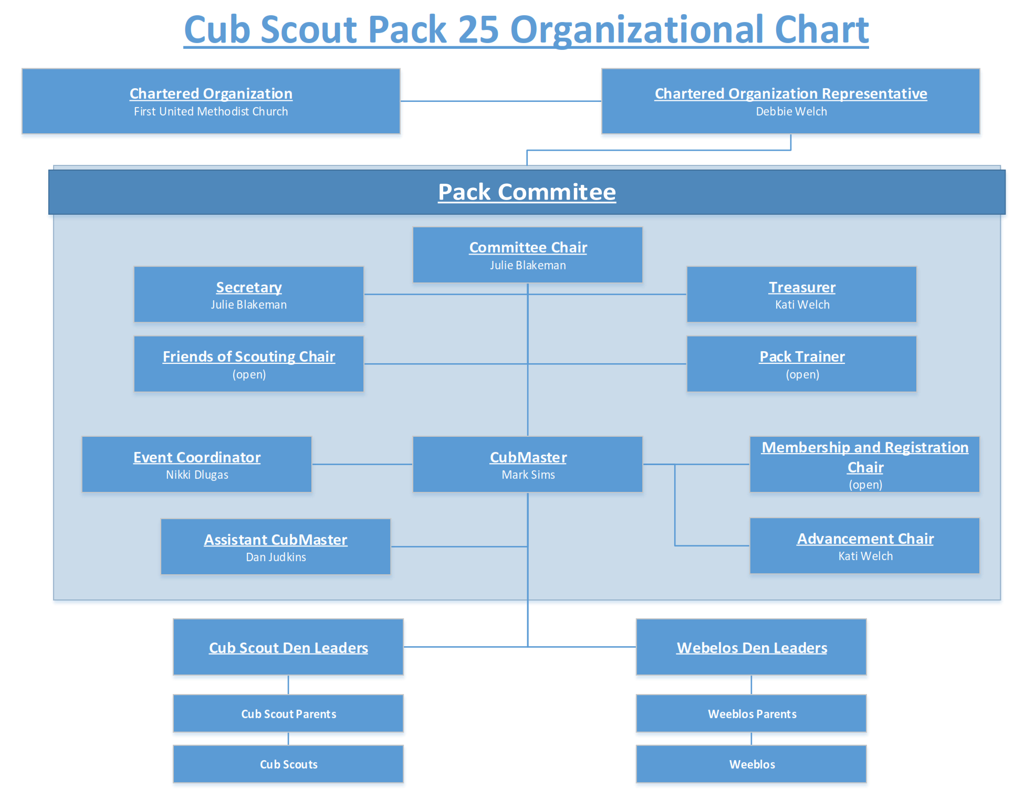

Pack Volunteer Leadership

Committee Chair
Conducts monthly pack leaders’ meeting to help plan program. Ensures that adequate support to run program is given to Cubmasters and den leaders by committee members. Helps recruit additional leaders as needed. Fast Start and Basic Leader Training are offered for this position to help new leaders succeed.

Committee Members
Attend monthly pack leaders’ meeting to help plan program and take care of records, finances, advancement, activities and membership. Fast Start and Basic Leader Training are offered for this position to help new leaders succeed.

Cubmaster
Conducts monthly pack meeting. Aids den leaders by coordinating monthly program for all leaders. Attends monthly pack leaders’ meeting. Fast Start and Basic Leader Training are offered for this position to help new leaders succeed.

Tiger Cub Den Leader
Coordinates shared leadership among the Tiger Cub adult partners. This ensures den meetings and outings are planned, prepared for, and conducted by all adult partners on a rotating basis and den activities provide advancement opportunities for the boys in the den. Serves as den host for family members at pack meetings. Attends monthly pack leaders’ meetings. Fast Start and Basic Leader Training are offered for this position to help the new leader succeed.

Cub Scout Den Leader
Meets weekly for about one hour with a den of six to eight boys. Den meeting is held in den leader’s home, a church, or other suitable place. The den leader determines time, day, and location of den meeting that is most convenient for him or her. Attends monthly pack leaders’ meeting. Both Fast Start and Basic Leader Training are offered for this position to help new leaders succeed.

Webelos Den Leader
Same as Cub Scout den leader except works with older Webelos Scouts. Encourages periodic parent/son overnight campouts. Attends monthly pack leaders’ meeting. Fast Start and Basic Leader Training are offered for this position to help new leaders succeed.

Pack Trainer
Conducts orientation for new families and pack leaders. Trains new leaders for their specific leadership positions or encourages participation in district training. Encourages pack leaders to attend ongoing training, such as roundtables and youth protection training. Conducts other training as designated. Keeps track of pack training records. Pack trainers should be trained in a district or council Trainer Development Conference. They should, of course, have completed a training session before they teach it.

Parent Helpers
Assist pack and/or den with specific projects as needed by the leaders. All parents help their sons with advancement. Review chapter 18, “Advancement,” of the Cub Scout Leader Book, No. 33221A, and the individual boy books for Tiger Cubs and Wolf Cub, Bear Cub, and Webelos Scouts.

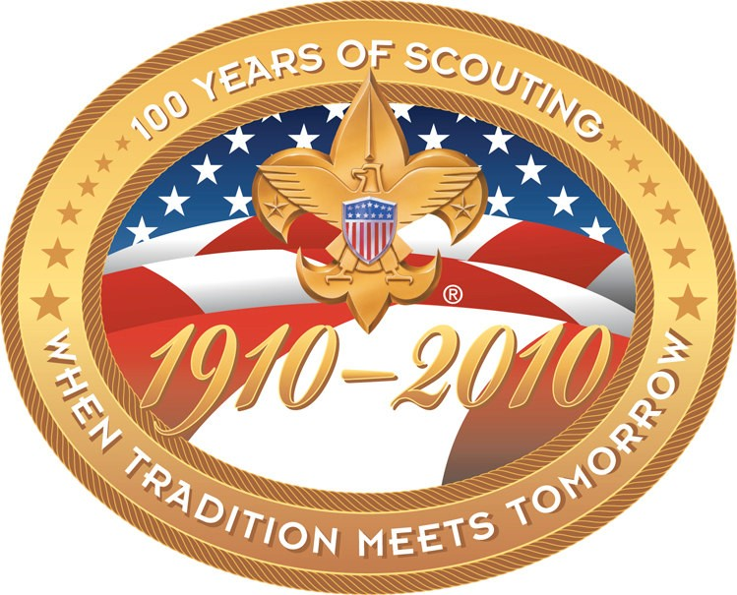
What is Cub Scouting?
The purpose of the Boy Scouts of America, as incorporated on February 8, 1910, and chartered by Congress in 1916, is to provide for boys and young adults an effective educational program designed to build desirable qualities of moral strength and character, to develop fitness, and to train in the responsibilities of active citizenship.

Since 1930, younger boys have had the opportunity to be Cub Scouts in a year-round, home- centered program that helps to strengthen the family. Cub Scouting (which includes Tiger Cubs, Cub Scouts, and Webelos Scouts) is the largest of the BSA’s program phases.

The other phases are Boy Scouting (which includes Varsity Scouting) and Venturing (which includes Sea Scouts).

�---------------------------------------

How Can I Help?
Parent involvement and leadership has been
Tell the Cubmaster how you will help

Organize a pack nature outing like: sledding, a hike, a bonfire, a picnic

a key to the success and growth of Pack Organize a pack sporting event

25. Being involved as a parent has great benefits like teaching your children service
outing like: Brewers, Bucks, Wave, Admirals, NASCAR, Marquette, UWM

through example, building relationships with Help with a Pack Night Activity
other families and the personal satisfaction Help Den Leaders with Den Meetings

of helping develop the character of our
and Outings

children. After experiencing the benefits Help with our Pinewood Derby scouting offers our boys most parents are Help with our Rocket Launch
more than willing to help whether it’s short Help with the Knights of Columbus

term or as a leader. If you have
Christmas and Easter Breakfasts

questions…just ask, we are a big scouting Help with our Blue and Gold Dinner family helping each other. Help organize our overnight Family
Camp
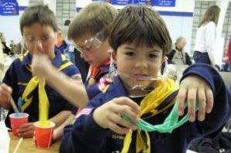
Help organize Swamp Fox
Help organize our pack Christmas Party
Help with the pack’s fundraiser popcorn sale
Represent Pack 262 at monthly Council Round Table Meetings
Be a Den Leader
Be a Pack Committee Leader
Other:

Important Information
Boy Scouts of America website address is: www.scouting.org My council is: Housatonic Council, www.housatonicbsa.org
My pack number is: 25
My pack website address is: www.scountlander.com
My pack typically meets on the first Friday of the month from September through June from 7:00 – 8:30pm in Long Hill Methodist Church Hall (see the calendar on the pack website for current meeting dates, times and locations.)

My CubMaster is: Mark Sims
203-893-1213
cubscoutpack25ct@gmail.com / simsmt@gmail.com
Pack 25’s Committee Chairperson is: Julie Blakeman
203-410-1107
Jmblakeman115@gmail.com

All correspondence from Pack 25 is delivered via email, posted on our FaceBook page, Cub Scout Pack 25, Shelton CT, and via scoutlander.com

Please be sure that you register with an email address that is checked frequently, so you don’t miss out on important events and notices.

Is it the discretion of the Den leaders to determine if communication within the den is via email, text or FaceBook.

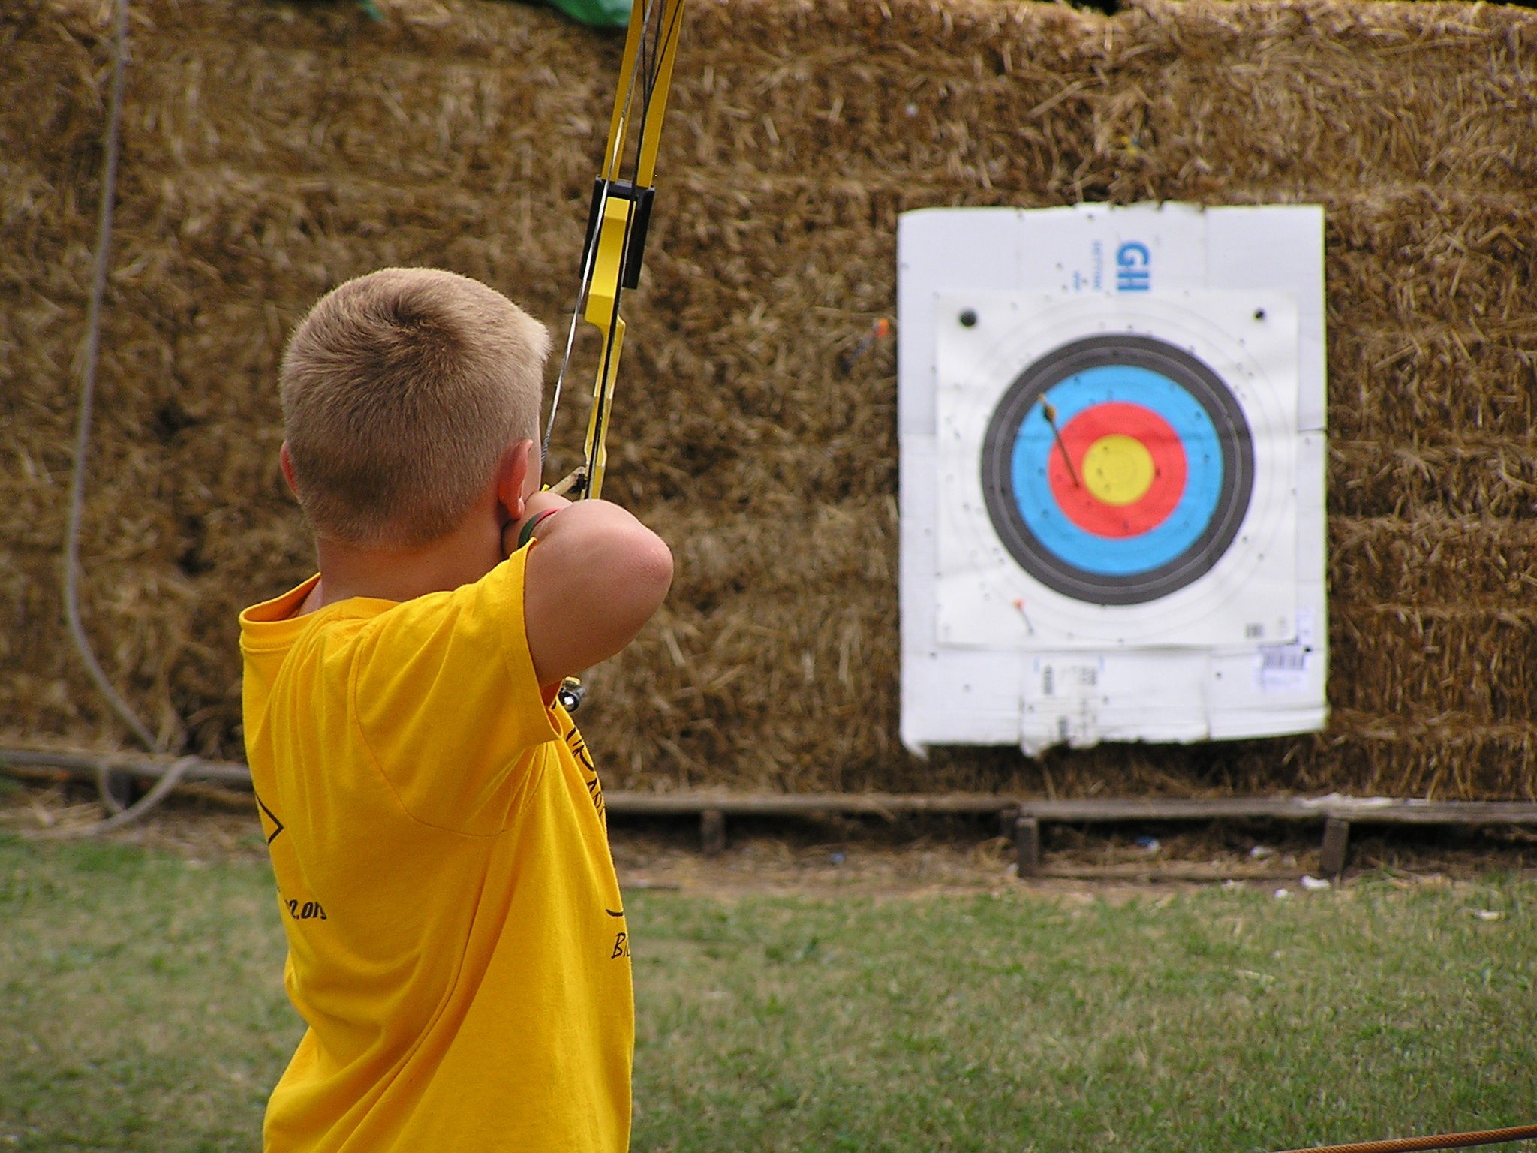
Housatonic Council BSA
111 New Haven Ave, Suite 10
Derby, CT 06418
203-734-3328

Milford Scout Shop
60 Wellington Road
Milford, CT 06461
203-876-0013

Online Scout Store:
www.scoutstuff.org

